CITY OF FAIRBANKS WINTER SNOW AND ICE POLICIES AND PROCEDURES November 2022

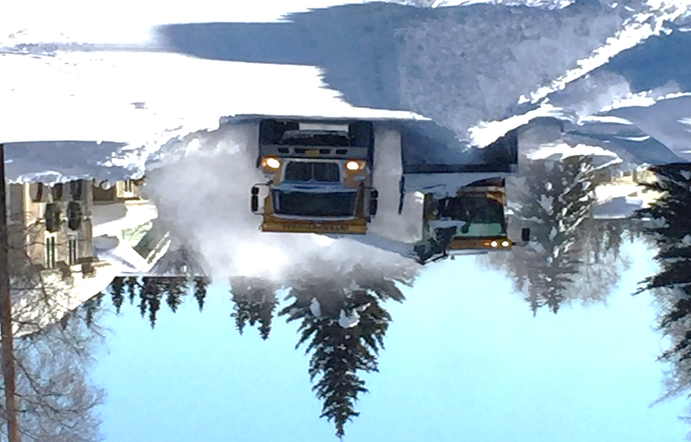
Loading snow in the neighborhoods to haul to one of the City of Fairbanks snow storage sites.
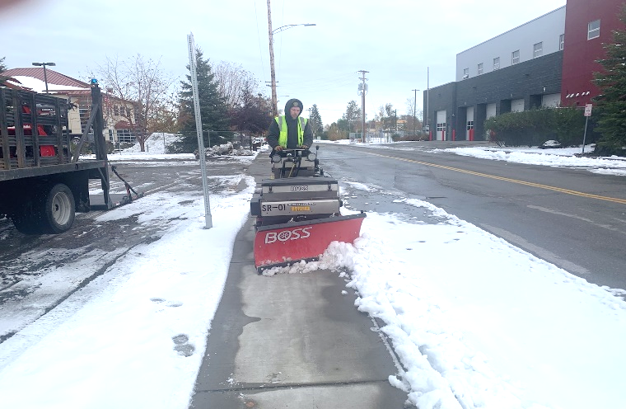
Laborers helping the streets crew clear the snow off the sidewalks to make it safe for city residents downtown.

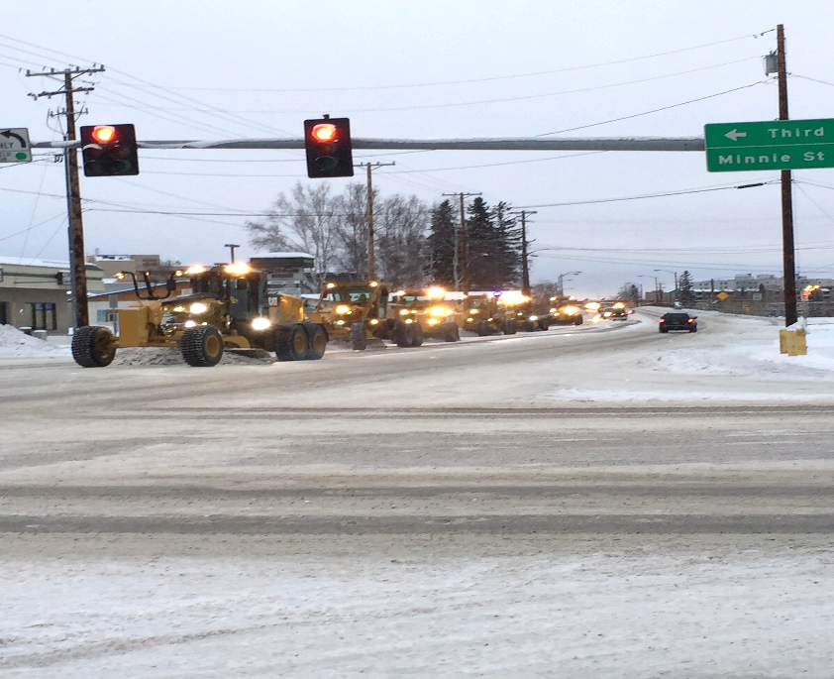
Graders teaming up on the Old Steese Hwy. to make short quick work on such a wide road, so we can get in and out of the way fast.
TABLE OF CONTENTS
PURPOSE …………………………………………………………………………………………………………….4
OBJECTIVE …………………………………………………………………………………………………………..4
SCOPE …………………………………………………………………………………………………………………4
RESPONSIBILITY ………………………………………………………………………………………………….5
TRAINING …………………………………………………………………………………………………………..5
WEATHER MONITORING ………………………………………………………………………………..….5
START OF SNOW AND ICE OPERATIONS …………………………………………………………….5
PRIORITIES ……………………………………………………………………………………………….…….….6
DEVIATION FROM POLICY ………………………………………………………………………….………6
EQUIPMENT RESOURCES ………………………………………………………………………….….…...7
CARE AND USE OF EQUIPMENT ………………………………………………………………….….….7
STAFFING …………………………………………………………………………………………………….…….8
RESPONSE PLAN ………………………………………………………………………………………….…….9
SIDEWALKS ………………………………………………………………………………………………….……10
CONTINUATION AND COMPLETION ………………………………………………………….………10
DAMAGES ………………………………………………………………………………………………...……..11
ACCIDENTS …………………………………………………………………………………………….…………11
SANDING ……………………………………………………………………………………………….…………11
SANDING MATERIAL …………………………………………………………………………………………12
BRIDGES …………………………………………………………………………………………………………..12
SNOW REMOVAL ……………………………………………………………………………………………..12
PUBLIC RELATIONS …………………………………………………………………………………………..12
DISPATCHING REQUESTS FOR SERVICE …………………………………………………………….12
PUBLIC INFORMATION …………………………………………………………………………………….13
APPENDIX INDEX ……………………………………………………………………………………………..14
HEAVY SNOW FALL EMERGENCY PLOW LISTS …………………………………………………15 – 17
HEAVY SNOWPLOW MAP ……………………………………………………………………………….18
HEAVY SNOW FALL SIDEWALK PLOW LISTs ……………………………………………….……19 – 22
SIDEWALK PLOW LIST …………………………………………………………………………………….23 – 29
NIGHT SHIFT WORK LIST …………………………………………………………………………………30 – 34
FINAL WORDS …………………………………………………………………………………………………35

PURPOSE
The purpose of this policy and procedures manual is to provide an understanding of priorities and procedures for plowing and picking up of snow during the winter season from November 1st to April 15th.
OBJECTIVE
The City of Fairbanks Public Works objective with these policies and procedures is to provide adequate traction for vehicles properly equipped for winter driving conditions and to assist in maintaining safe and accessible sidewalks for the walking and biking public. It should be expected that during heavy snow falls and long snow fall durations that drivers and pedestrians will encounter snow-packed and icy roads and sidewalks. Priority of roads is given to arterial and major collectors before residential roads and sidewalks. Be assured that Public Works is working to provide safe passable roads and to assist Police, Fire and Emergency Medical Services in fulfilling their duties. Snow and ice control operations will continue until all streets are passable or when plowing and sanding is no longer needed.
It is also Public Works intent to move through the plowing of snow and ice as fast as safely possible, to attempt a minimum of inconvenience to the public as possible. Please give the equipment a safe distance and be patient as we are trying to make the roads safe for the citizens of the Fairbanks area.
SCOPE
This snow and ice manual is Public Works guide to follow while plowing and picking up snow and ice on City streets, City parking lots and sidewalks. Furthermore, the manual only applies to City streets, parking lots and sidewalks under the City of Fairbanks maintenance agreements.
Fairbanks General Code Section 70-321. Snow and Ice; removal; standing; casting on public property.
- A person having control of any premise boarded by a graded or paved sidewalk must promptly remove any snow which falls on the sidewalk and must remove or sand any ice which forms on the sidewalk, to the extent that the snow or ice is not an impediment to pedestrians.
- It is unlawful for any person to move snow or ice from private property onto any sidewalk, street, avenue, or alley in the city to the extent that the snow or ice is an impediment to use of the sidewalk, street, avenue, or alley. It is not a violation to move snow from the sidewalk off the adjacent curb.
RESPONSIBILITY
Fairbanks City Ordinance 6061 puts the responsibility of snow and ice removal on the Public Works Department. The goal for snow plowing is to open all arterial and collector roads within 48 hours, followed by clearing of streets in residential neighborhoods and clearing sidewalks and curb ramps throughout the city. Public Works maintains 355 lane miles of roadway, 97 miles of storm drain piping, and 30 miles of sidewalks.
The implementation of this policy lies with the Streets Supervisor, or designee during off hours.
TRAINING
Prior to the start of the snow season, the Streets Division will conduct training activities for personnel that will be involved in the snow control activities. Training will consist of hands-on equipment training and the driving and inspection of streets, parking lots and sidewalks within the Public Works maintenance agreements.
WEATHER MONITORING
The Streets supervisor will use the National Weather Service daily forecasts to monitor weather conditions. The Street supervisor is responsible for scheduling the snow crews’ actions based on these forecasts.
START OF SNOW AND ICE OPERATIONS
The start of snow and ice operations is determined by the actual snow fall depth of 3 inches, or less than 3 inches if combined with freezing rain or icy road conditions.
Less than 3 inches of snow will be allowed to pack down until the street is plowed and picked up in its set rotation for the season. Sand trucks will be dispatched to sand traffic intersections and other slick areas throughout the city.
More than 3 inches of snow fall depth with no forecasted above freezing temperatures will be plowed to the edges or curbs of roads and scheduled for collection and hauled away to a snow storage site.
After the priority routes are plowed, equipment will then be dispatched to the neighborhoods to smooth up streets and to start or continue snow collection in the neighborhoods.
The downtown core area will only have snow removal done by a night crew. In a typical winter, snow will be removed from the downtown core area 3 to 5 times.
These operations performed by Public Works attempt to maintain travel-safe walks and roadways for pedestrians and vehicles properly equipped for winter travel conditions.
PRIORITIES
In an efficient manor, the necessity of certain high used roads has priority over other less used roads. Therefore, streets with higher intensity use have a higher priority of snow plowing and removal service. Minor streets which require proportionally more time for snow plowing and removal for traffic served have a low priority.
City streets have been divided into the following snow plowing and removal priority categories:
PRIORITY 1: These are arterial and major collector streets to include schools, hospital, and emergency services.
PRIORITY 2: These are minor collector streets to include the business district and bus routes.
PRIORITY 3: All other streets that are not designated as either Priority 1 or 2 streets.
A heavy snow fall map, heavy snow fall plow routes and street priority list for night shift is included in the appendix.
City parking lots are picked up by the night shift and sanding is typically done in the morning or as requested.
DEVIATIONS FROM POLICY
Deviations from policies and procedures may occur due to unusual or extraordinary circumstances. No two snowfalls are alike, and each has unique challenges and characteristics from intensity, duration, wind, and temperature that influence the response to each snowfall.
Deviations and exceptions to this snow and ice policy and procedures manual may be altered when, in the judgement of Public Works, such deviations will best support meeting established objectives and ensure public safety.

EQUIPMENT RESOURCES
Public Works deploys a variety of equipment to plow and pickup snow:
- Eight (8) motor graders
- Fifteen (15) dump trucks (one of which can double as a sander when the box is swapped out)
- Two (2) tractors with side dumps
- Eight (8) snow loaders
- Five (5) front-end loaders (one of which can be equipped with a plow)
- Three (3) sand trucks
- Three (3) skid steers (these can be fitted with snowplows and snow blowers)
- Three (3) holders (these can be fitted with snowplows or 1 with a snow blower)
- One (1) backhoe
- Two (2) snowrator
- One (1) small tractor (this can be fitted with a snowplow)
In recent years, Public Works has rented tractors equipped with side dumps to help in the hauling of snow and speed up the snow removal process.
CARE AND USE OF EQUIPMENT
The equipment operator that is assigned to a piece of equipment is the first line of maintenance and safety inspection. The operator is responsible to do daily greasing, fluid checks and safety walk around.
A walk around should consist of an inspection of the vehicle’s tires, drive train, window glass, lights, reflectors, heater and all its functions, mirrors, and any attachment. Equipment walkaround sheets need to be filled out at start of shift and a shop repair sheet needs to be filled out for any repairs needed and turned in at the end of shift or given to the shop for repairs.
Attachments should be inspected for functionality and if it is performing to anticipated expectations. Damages and wear items need to be replaced if needed and greased if needed before heading out to the field.
OBEY ALL TRAFFIC LAWS AND WATCH OUT FOR TRAIN TRAFFIC AT ALL CROSSINGS

Report any non-working equipment immediately to the shop supervisor or shop lead.
Use reasonable caution in operation of snow and ice removal equipment.
Do not drive too fast.
Slowdown in tight areas throughout the city.
Be mindful of hidden objects in the snow or under the ice and use caution.
DO NOT follow cars and other snow removal equipment too closely.
Snow and ice equipment are essential, but they must obey all traffic laws. Flashing blue lights on Public Works equipment is to alert others and does not pre-empt right of way.
STAFFING 2022
Public Works Streets Division personnel consists of:
- Eight (7) permanent operators
- One (1) permanent operator lead
- One (1) Street supervisor
Public Works Maintenance Shop personnel consists of:
- Five (5) permanent mechanics
- One (1) emergency apparatus technician
- One (1) permanent shop lead
- One (1) parts expediters
- One (1) Mechanic supervisor
Public Works Labor Department personnel consists of:
- Eight (5) permanent laborers
- Three (3) packer drivers
- One (1) permanent labor lead
- One (1) labor supervisor
During the winter season, Public Works hires temporary operators to fill the snow crews and aid the shop. As the budget allows for a night shift to be staffed, it doubles our efforts in snow plowing and removal. At Public Works, the day shift schedule is from 7:00 AM to 5:30 PM, Monday through Thursday and if there is a nightshift their schedule is from 9:00 PM to 7:00 AM, Monday through Thursday. During heavy snow falls, Public Works will work overtime as needed.
Minimum preferred staffing for the day and night shift are outlined below. Public Works needs to hire 33 temporary operators from the Local 302 to fill the crews on heavy snow falls.

Day Shift Night Shift
- 2 sidewalk machines as needed 1 sidewalk machine
- 3 graders 3 graders
- 1 sander 1 sander
- 1 blower 1 blower
- 1 loader 1 loader
- 12 dump trucks 10 dump trucks
- 2 Side dump 2 Side dump
The crew size fluctuates as the need for employees rises and falls, dependent on the snow load at hand or forecasted snow load.
RESPONSE PLAN
With a snowfall of less than 3 inches of snow, sand trucks are sent out to sand arterial intersections and patrol for slick areas and corners throughout the city.
The snow is left to compact down or blow from the driving path and is then plowed up or picked up, depending on the schedule of when the road was scheduled for snow and ice control or to be picked up. Neighborhoods are left to pack down and graders are dispatched to smooth up roads until their scheduled day of snow removal. Sand trucks are sent to check for slick intersections in neighborhoods.
With a snowfall greater than 3 inches of snow, graders are sent out to plow Priority 1 routes until they are determined to be safe for travel. Snow plowing operations then switch to Priority 2 routes and addressing the neighborhoods. Sidewalk machines are also sent out at this time to help residents plow the snow off the sidewalks.
Priority 3 routes will be started as soon as priority 2 routes are determined to be safe, and the sidewalks are complete. If it is determined that the condition of higher priority routes start deteriorating, the focus will shift back to the higher priority routes.
During the plowing process, Public Works graders will do what it can to minimize or avoid putting snow or ice in front of driveways and mailboxes. However, in the process of plowing, some of the excess snow will fall around the gate (commonly referred to as gating) leaving small berms or ice chunks.
It is the responsibility of the property owner to clear this excess snow from in front of their driveway or mailbox. It is not productive for the graders to make multiple passes while trying to open the roads for safe travel.
It is against City ordinance to blow, plow or shovel any snow from a driveway or property out into the road or right of way, or on to sidewalks, as per City Code Section 70-321.

Public Works does not pick up piles pushed up from the right of way to clear a berm from a parking area alongside the street. Instead to clear a berm from a parking area the berm should be moved to alongside or incorporated into the existing berm in that area. The resident created piles cost the taxpayers 4 times the amount of Public Works resources to remove with a loader and trucks then it does with a blower and trucks. There is also no telling the debris in the pile that can damage equipment.
SIDEWALKS
Laborers hand shovel or use walk behind blowers to remove snow from bridges downtown (Cushman, Veterans and Wendel St.), handicap ramps from Barnette Street to Noble Street, and from 1st Avenue to 12th Avenue. Most of Cushman Street including City Hall and the Police Department are addressed, as well as the pedestrian walkway connecting Bridgewater Drive to Aurora Drive and the traffic diverters on 21st Avenue and 27th Avenue. The bridge on Minnie St and Aurora are also hand shoveled by the Laborers.
Public Works uses small articulated tractors to plow sidewalks with the current fleet of four tractors. Public Works helps property owners with sidewalk snow removal when time permits, and employees are available. As per City Code Section 70-321 a, and 70-321 b, it is the responsibility of the property resident to promptly remove snow and ice from sidewalks adjacent to the property and sand if needed. Its ok for a resident to push the snow off the sidewalk onto the curb edge but not to pile it up.
CONTINUATION AND COMPLETION
It normally takes the Public Works snow crew AFTER the snow stops falling a minimum of 48 hours to plow and sand the Priority 1 routes, including schools and emergency services.

Priority 2 routes and residential streets take an additional minimum of 72 hours to plow and sand, assuming there are no unforeseen interruptions and optimal staffing levels.

Priority 3 routes tend to get packed down and icy and, in this case, it can take an additional 72 to 96 hours before they can be finished being plowed and sanded.

The city is divided into seven geographic residential areas/neighborhoods. Plowing the neighborhoods in these seven areas takes 3 to 4 days depending on staffing levels. It takes approximately 4-6 weeks to get through all the residential neighborhoods for snow removal, before the next round of snow removal begins. Depending on snow volumes, removal of snow berms will occur 1-2 times per winter.
Once all roads are plowed, Public Works starts picking up the berms to widen the roads. Priority 1 routes, Priority 2 routes and City parking lots are picked up on a night shift, while neighborhoods will start to be picked up on the day shift. Neighborhoods that cannot be plowed and must be picked up will be worked into the schedule. The neighborhoods are on a once-a-year rotation with the first neighborhood falling to the bottom of the list and the rest moving up each year.
DAMAGES
Damage is sometimes unavoidable when plowing, but the operators try their best to avoid any damage. Damages done to mailboxes, fences planters and lawns should be reported immediately to the Street Supervisor. If it is deemed by the supervisor to be damage due to operations, the damage will be logged for repairs by Public Works and the resident or business will need to file the claim with the City Risk department.

Public Works has an extension pole that can be used to raise low-hanging cable and phone lines, but the appropriate authority on these lines should be notified to raise them.
ACCIDENTS
Public Works equipment and vehicles must report all accidents immediately to their supervisor, so that circumstances can be thoroughly investigated. The supervisor will call the police to notify them of the accident, if warranted, and an incident report will be filled out. Operators who are involved in a crash may also be subject to a drug and alcohol test in accordance with the rules and regulations of their CDL’s.
SANDING
Sanding is done after the plowing of a street is complete or when roads are icy. Depending on street conditions, sanding will be done multiple times until traction is restored or is determined no further sanding is needed. When conditions warrant – sanders are deployed at 6am and on weekends.
SANDING MATERIAL
Public Works uses a 3/8 crushed gravel for sanding purposes. No salt or brines are used by Public Works in its sanding operation.
BRIDGES
Bridges are often icy before adjacent streets and are monitored for icy conditions and sanded often. Always use caution when crossing bridges during bad weather.
SNOW REMOVAL
The process of loading and hauling snow is the most expensive and time-consuming winter season process for Public Works. During the snow season, Public Works intention is to staff the extra needed employees with temporary operators to adequately handle most of the snow and ice operations during a typical snow season. It is impractical to assume we will have all our equipment operating at once. Provisions are made for equipment needing repairs and employee shortages for any number of reasons. Public Works goal is to keep at least 85% of the snow and ice removal equipment out in the field and operational during the winter snow and ice season.
PUBLIC RELATIONS
Information is a key component in our efforts to inform the public as to what Public Works will be doing during the winter snow and ice season. Information will be shared with the public in a few different ways ranging from posting on the City website and Facebook page, flyers with the refuse collection bill, reader boards and “No Parking” cones placed in the streets and around vehicles that have not moved in over 24 hours.

Prior to the winter snow and ice season, a winter maintenance forum is put on by Fairbanks Fast Planning that has the heads of Public Works, DOT, UAF, North Pole and the Fairbanks North Star Borough. Each agency talks about their current snow and ice removal operations.
DISPATCHING REQUESTS FOR SERVICE
Residents can notify Public Works of unsafe conditions or needs by calling Public Works at 907-459-6770. Calls are logged and forwarded to the street supervisor for review and follow up. These logs are then used to dispatch the snow removal crew after the goals of this policy have been met. The Street supervisor will be notified of any hazardous conditions on the roads or in neighborhoods that need to be addressed urgently.

PUBLIC INFORMATION
Plowing around parked vehicles and trailers is very time consuming, less efficient and results in snow being left around the vehicle. Posting should be done a minimum of 12 hours before the snow crews arrive to remove snow from an area, per City Ordinance No. 78-389. For snow removal, vehicles should be moved after posting has been made to notify the residents of an area that snow removal will be done in. Posting consists of orange signage placed throughout neighborhoods with a start time for the following day and at times includes electronic billboards.

It is also against city code and ordinance to leave a car parked on the side of the road for longer than 24 hours. A trailer cannot be parked on city-maintained street or highway for longer than 1 hour at any one time, per City Ordinance No. 78-391 and 78-397, especially during snow removal operations.

It is against city ordinance to blow, plow or shovel any snow from a driveway or property out into the road or right-a-way, per City Code Section 70-321, and should be done as shown below.

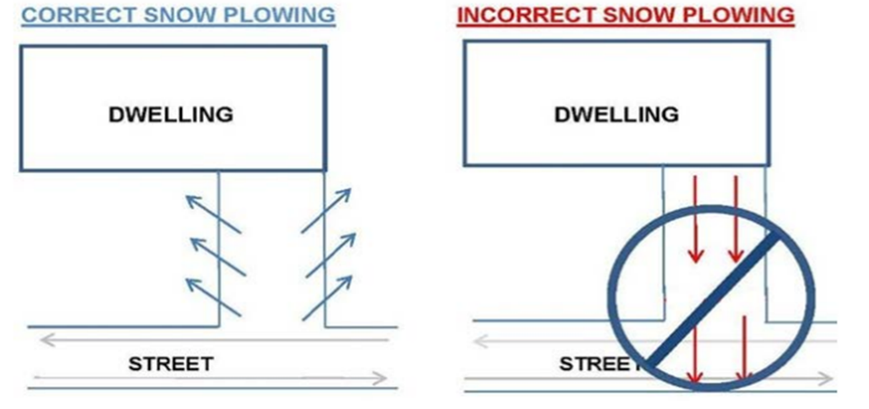
APPENDIX INDEX

Heavy Snowfall Emergency Lists
Route 1
Route 2
Route3
Heavy Snowfall Emergency Snowplow Map
Streets maintained by State of Alaska, Department of Transportation, Within the City Limits
Heavy Snowfall Sidewalk Plow List
Route 1
Route 2
Sidewalk Plow List
Nightshift Work List

HEAVY SNOW FALL EMERGENCY PLOW LIST
2 BLADES ON ROUTE 1 / 3 BLADES IF POSSIBLE, ON ROUTE 2
3 BLADES ON ROUTE 3
Route | Location | From/To | Date Plowed
1 | Lathrop Street | Mitchel Expressway to Cowles St. Y
1 | Cowles Street | Cowles St. Y to Airport Way
1 | East Cowles | Cowles Street to 23rd Ave
1 | 23rd Ave | Lathrop to South Cushman Street
1 | South Cushman Street | Airport Way to 28th Ave on ramp
1 | 17th Ave | South Cushman Street to East Cowles
1 | Gillam Way | 17th Ave to Airport Way
1 | 16th Ave | Gillam Way to Schaible Street
1 | Schaible Street | 16th Ave to 14th Ave
1 | 15th Ave | Schaible Street to Gillam Way
1 | Wilbur Street | Airport Way to Davis Road
1 | Eagan Ave | Wilbur Street to Moore Street
1 | Moore Street | Eagan Ave to Dead End
1 | 19th Ave | Peger Road to Kiana Street
1 | Kiana Street | 19th Ave to 17th Ave
1 | 17th Ave | Kiana Street to Roosevelt Street
1 | Market Street | 17th Ave to Airport Way
1 | Roosevelt Street | 17th Ave to Adams Drive
1 | Adams Drive | Roosevelt Street to Washington Drive
1 | Washington Drive | Adams Drive to Airport Way
1 | Rewak Drive | Washington Drive to University Ave
Pull sidewalks where you can. Note it in the notes what side you pulled or if you pulled both sides.

HEAVY SNOW FALL EMERGENCY PLOW LIST
2 BLADES ON ROUTE 1 / 3 BLADES IF POSSIBLE, ON ROUTE 2
3 BLADES ON ROUTE 3
Route | Location | From/To | Date Plowed
2 | Cushman street | Airport Way to 1st Ave
2 | 1st Ave | Cushman Street to Barnette Street
2 | Barnette Street | 1st Ave to Airport Way
2 | Gaffney road | Barnette Street to Noble Street
2 | Illinois Street | 1st Ave to College Road
2 | 10th Ave | Barnette Street to Steese Hwy
2 | 10th Ave | Barnette Street to Dead End
2 | West Barnette Street | 10th Ave to Dead End
2 | 12th Ave | Cushman Street to Federal Building
2 | 11th Ave | Cushman Street to Dead End
2 | Lacey Street | 1st Ave to 12th Ave
2 | Noble Street | Airport Way to Wendell Ave
2 | Wendell Ave | Noble Street to 3rd Street
2 | Minnie Street | 3rd Street to Illinois Street
2 | Betty Street ( north side ) | Minnie Street to Dead End
2 | Monroe Street | Minnie Street to Monroe School
2 | Driveway Street | Phillips Field rd. to Terminal Street
2 | Terminal Street | Borough Parking Lot to Illinois Street
2 | 1st Ave | Barnette Street to Cowles Street
2 | Cowles Street | 1st Ave to Airport Way
2 | 1st Ave | Cowles Street to Lathrop Street
2 | Lathrop Street | 1st Ave to Airport Way
2 | 10th Ave | Stewart Street to Cowles Street
2 | Stewart Street | 10th Ave to Crosson Ave
2 | Crosson Ave | Stewart Street to Lathrop Street
2 | Lower Second Ave | Lathrop Street to Moore Street
2 | Moore Street | Lower Second Ave to Airport Access
2 | Wilbur Street | Lower Second Ave to Airport Road
Pull sidewalks where you can. Note it in the notes what side you pulled or if you pulled both sides.

HEAVY SNOW FALL EMERGENCY PLOW LIST
2 BLADES ON ROUTE 1 / 3 BLADES IF POSSIBLE, ON ROUTE 2
3 BLADES ON ROUTE 3
Route | Location | From/To | Date Plowed
3 | Wembly Street | Danby Street to Aurora Drive
3 | Aurora Drive | Wembly Street to College Road
3 | Hampstead Ave | Danby Street to School /Dead End
3 | Bainbridge Blvd | Danby Street to School /Dead End
3 | Margaret Ave | College Road to Dead End
3 | Old Steese Hwy/Northside Blvd | Harold Bentley Ave to 3rd Street
3 | Helmericks Ave | Old Steese to Bentley Trust
3 | Bentley Trust Rd | College to Old Steese
3 | Hamilton Ave | Farewell Ave to Slater Drive
3 | Hamilton Ave | Farewell Ave to Adak Ave
3 | Farewell Ave | Hamilton Ave to Trainor Gate Road
3 | Trainor Gate Road | G Street to Old Steese Hwy
3 | F Street | Trainor Gate Road to Baranof Ave
3 | Baranof Ave | F Street to Trainor Gate Road
3 | Eagle Ave | Bentley Drive to 4th Street
Pull sidewalks where you can. Note it in the notes what side you pulled or if you pulled both sides.

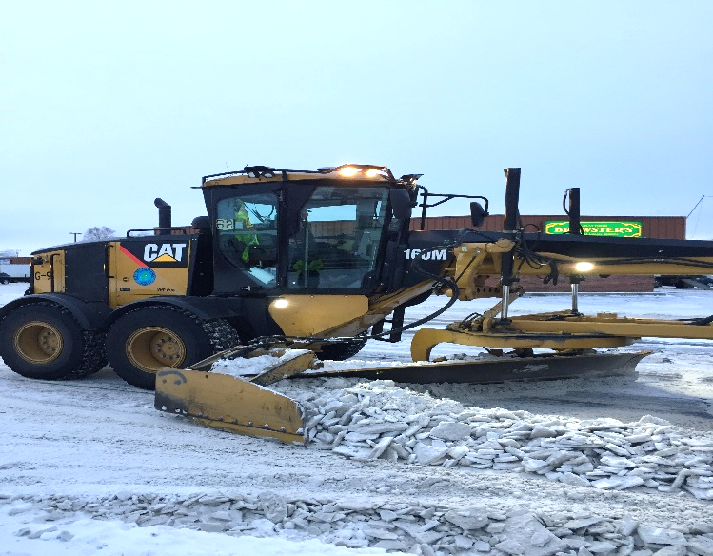
Heavy Snowfall Emergency Snowplow map
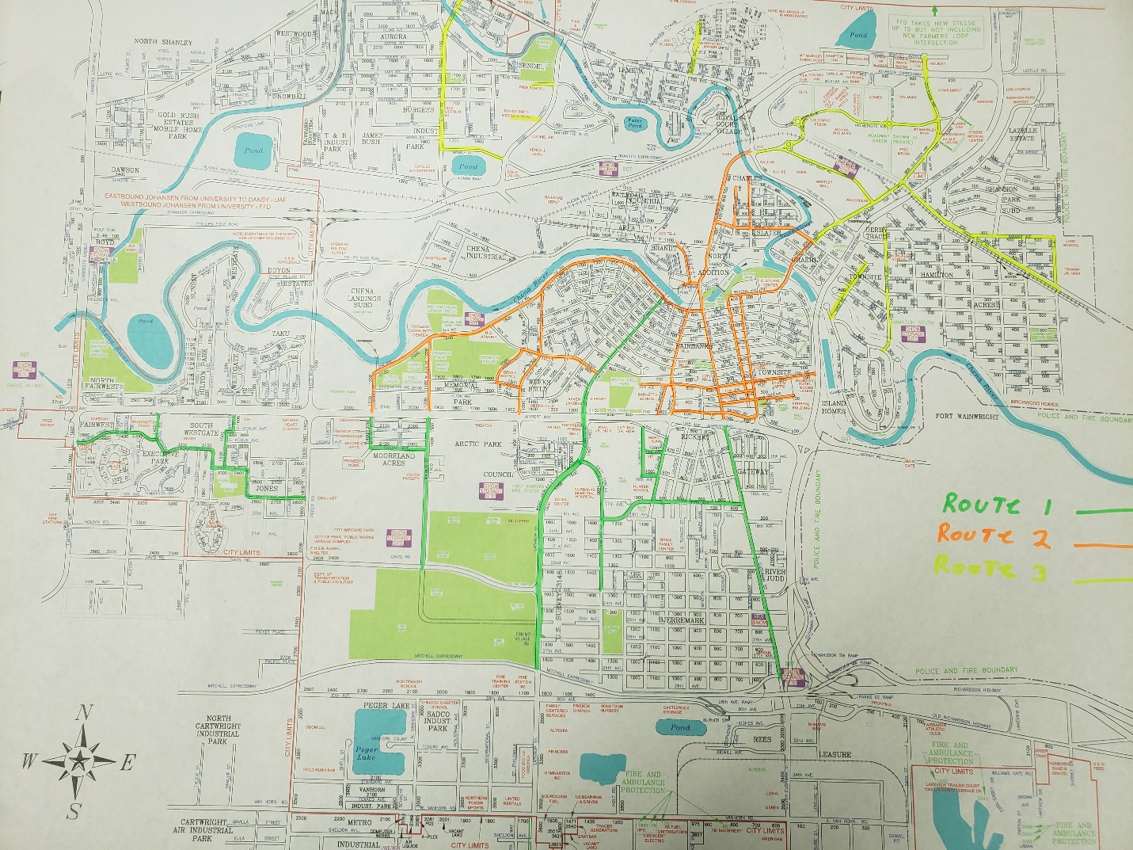

STREETS MAINTAINED BY STATE OF ALASKA, DEPARTMENT OF TRANSPORTATION, WITHIN THE CITY LIMITS
Johansen Expy. and all entries and exits to it.
Airport Frontage roads except ( West of Market St. and west of Washington Dr. and south of Airport Rd.)
Peger Rd.
Van Horn Rd.
Davis Rd. from Lathrop St., west to University Ave.
University Ave.
Mitchell Expy. and all entries and exits to it.
New Richardson Hwy. and all entries and exits to it.
Geraghty Dr. east of University Ave. to Washington Dr.

New Steese Hwy.
3rd St. in Graehl (from Old Steese Hwy. to Hamilton Ave.)
Airport Rd.
S. Cushman St. extension south of 28th Ave.
Old Richardson Hwy. southeast of 30th Ave.
Easy St. (by Teamsters Mall)
30th Ave. east of Peger Rd. to S. Cushman St.
23rd St. east of S. Cushman St.
College Rd.
Lathrop St. south of 27th Ave.
Phillips Field Rd.
Danby Ave.

HEAVY SNOWFALL SIDEWALK ROUTE 1
AREA | LOCATION | FROM / TO | COMMENTS | Date Plowed
5 | Davis Rd. | Public Works to Lathrop St. | North Side
2 | Lathrop St. | 27th Ave. to Cowles St. Y
2 | 23rd Ave. | Lathrop St. to S. Cushman St.
2 | E. Cowles St. | Cowles St. Y to 23rd. Ave.
2 | 19th Ave. | E. Cowles St. to 17th Ave.
2 | 17th Ave. | Gillam Way to S. Cushman St.
2 | Gillam Way | Airport Way to 17th Ave.
2 | S. Cushman St. | 28th Ave. to Gaffney Rd.
3 | Cushman St. | Gaffney Rd. to 1st Ave.
3 | Lacey St. | 12th Ave. to 1st Ave. | East Side
3 | Noble St. | Gaffney Rd. to Wendell Ave. | East Side
3 | Wendell Ave. | Noble St. to Wendell Bridge
4 | Bentley Trust Rd. | College Rd. to Old Steese Hwy. | North Side
4 | Helmericks Ave. | Old Steese Hwy. to Bentley Trust Rd. | North Side
1 | Old Steese Hwy. | Wendell Bridge to Trainor Gate Rd.
1 | Trainor Gate Rd. | Old Steese Hwy. to Tanana Middle Parking Ent. | North Side
1 | F St. | Trainor Gate Rd. to Baranof Ave. | East side
1 | Farewell Ave. | Hamilton St. to Trainor Gate Rd. | Can be done with skiddy snowblower
1 | Hamilton Ave. | Farewell Ave. to Craig Ave. | East side
1 | Craig Ave. | Hamilton Ave. to A St. | South side to the bus ent. at back of school
1 | A St. | Dunbar Ave. to Eureka Ave.
1 | Eureka Ave. | A St. to Hamilton Ave.
1 | Hamilton Ave. | Farewell Ave. to Northern Con. & Equip.

HEAVY SNOWFALL SIDEWALK ROUTE 2
AREA | LOCATION | FROM / TO | COMMENTS | Date Plowed
2 | Cowles St. | Cowles St. Y to 10th Ave.
2 | Cowles St. | 10th Ave. to 1st Ave. | East Side
5 | Lower 2nd Ave. | Grant St. to Wilber St. | Can blow some of this sidewalk with Skiddy snowblower
3 | Lathrop St. | Lower 2nd Ave. to Airport Frontage Inter. | West side East side do what we can otherwise pulled by grader on pick up
5 | Crosson Ave. | Lathrop St. to Stewart St. | North side.
5 | Stewart St. | Crosson Ave. to 10th Ave. | East side
3 | 1st Ave. | Cowles St. to Grant St.
3 | 1st Ave. | Cushman St. to Cowles St. | North Side and can be done with Skiddy snowblower
3 | Barnette St. | 1st Ave. to Airport Rd.
3 | W Barnette St. | 10th Ave. to Dead End | Sidewalk on west side along school playground.
3 | W 10th Ave. | Barnette to School parking | Sidewalk is only on south side of the road.
3 | 10th Ave. | West 10th Ave. to Steese HWY.
4 | Illinois St. | 1st Ave. to College Rd. | Barnette Bridge Included
4 | Wembly St. | Danbey St. to Aurora Dr. | North Side
4 | Aurora Dr. | Hanson Rd. to College Rd.
4 | Margaret Ave. | College Rd. to School Parking | West side to last ent. of schools parking East side stops at entrance to housing
5 | Washington Dr. | Airport Rd. to  Rewak Dr. | West Side
5 | Rewak Dr. | University Ave. to Washington Dr.
5 | Wilbur St. | Airport Rd. to  Lower 2nd Ave.
5 | Wilbur St. | Eagan Ave. to  Airport Rd.
5 | Wilbur St. | Davis Rd. to  Eagan Ave. | East Side and can be done with Skiddy snowblower

Sidewalk Plow List
Sidewalk on both sides unless otherwise stated in comments.
Priority | AREA | LOCATION | FROM / TO | COMMENTS | Date Completed
1 | 5 | Davis Rd. | Public Works to Lathrop St. | North Side
1 | 2 | Lathrop St. | 27th Ave. to Cowles St. Y
1 | 2 | East Cowles St. | Cowles St. Y to 23rd. Ave
1 | 2 | Cowles St. | Cowles St. Y to 10th Ave.
1 | 2 | Lathrop St. | 23rd Ave to 27th Ave.
1 | 2 | 23rd Ave. | Lathrop St. to S. Cushman St.
1 | 2 | S. Cushman St. | 28th Ave. to Gaffney Rd.
1 | 2 | Gillam Way | 17th Ave. to Airport Way
1 | 2 | 19th Ave./17th Ave. | E. Cowles St. to Gillam Way
1 | 2 | 17th Ave. | Gillam Way to S. Cushman St.
1 | 2 | Cowles St. | 10th Ave. to 1st Ave. | East Side West 1st to 5th pull with grader when picked up
1 | 3 | 1st Ave. | Cushman St. to Cowles St. | North Side and can be done with Skiddy snowblower / Both sides are plowed
1 | 3 | 1st Ave. | Cowles St. to Grant St.
1 | 5 | Lower 2nd Ave. | Grant St. to Wilbur St. | Can blow some of this sidewalk with Skiddy snowblower / Both sides are plowed
1 | 5 | Wilbur St. | Airport Rd. to Lower 2nd Ave.
1 | 5 | Wilbur St. | Eagan Ave. to Airport Rd.
1 | 5 | Wilbur St. | Davis Rd. to Eagan Ave. | East Side and can be done with Skiddy snowblower as well
1 | 3 | Barnette St. | 1st Ave. to Airport Way
1 | 3 | 10th Ave. | School to Barnette St. | South Side / Both sides at Barnette St. intersection
1 | 3 | W. Barnette St. | Dead End to 10th Ave. | West side
1 | 3 | 10th Ave. | Barnette St. to Turner St. | North and South side where we can otherwise pull with grader when picked up
1 | 3 | 10th Ave. | Turner St. to Cushman St. | North Side South side pull with grader when picked up
1 | 3 | Lathrop St. | 1st Ave to Airport Frontage Inter. | West side East side do what we can otherwise pull with grader when picked up
1 | 3 | Cushman St. | Gaffney Rd. to 1st Ave.
1 | 3 | Noble St. | Gaffney Rd. to Wendell St. | No sidewalk from 5th Ave. to mid-block on the way to 6th Ave.
1 | 3 | Lacey St. | 12 Ave. to 1st Ave. | East side can be done with holder West side pull with grader when picked up
1 | 3 | 10th Ave. | Cushman St. to Steese Hwy. | Plow where we can otherwise pull with grader when picked up
1 | 4 | Illinois St. | 1st Ave. to College Rd. | Barnette Bridge Included
1 | 4 | Bentley Trust Rd. | College Rd. to Old Steese Hwy. | North Side Both sides at round a bout to College
1 | 4 | Helmericks Ave. | Old Steese Hwy. to Bentley Trust Rd. | North Side
1 | 1 | Old Steese Hwy. | Wendell Bridge to Trainor Gate Rd.
1 | 3 | Wendell Ave. | Noble St. to Wendell Bridge
1 | 1 | Trainor Gate Rd. | Old Steese Hwy. to Tanana Middle Parking Entrance | North Side
1 | 1 | F St. | Trainor Gate Rd. to Baranof Ave. | East side
1 | 1 | Farewell Ave. | Hamilton Ave. to Trainor Gate Rd. | Can be done with skiddy snowblower / Do both sides
1 | 1 | Hamilton Ave. | Farewell Ave. to Craig Ave. | East side
1 | 1 | Craig Ave. | Hamilton Ave. to A St. | South side to the bus ent. at back of school
1 | 5 | Washington Dr. | Airport Rd. to Rewak Dr. | West Side
1 | 5 | Rewak Dr. | University Ave. to Washington Dr.
1 | 4 | Wembly St. | Danby St. to Aurora Dr. | North Side
1 | 4 | Aurora Dr. | Hanson Rd. to College Rd.
1 | 4 | Margaret Ave. | College Rd. to School Parking | West side to last ent. of schools parking East side stops at entrance to housing
2 | 2 | Kennicott Ave. | Cowles St. to Bluebell St. | North side pull with grader when picked up South side can be plowed
2 | 2 | Bluebell St. | Kennicott Ave. to McCarty Ave. | West Side
2 | 2 | E. Cowles St. | 23rd Ave. to 24th Ave. | East side
2 | 2 | E. Cowles St. | 27th Ave. to 29th Ave. | West Side
2 | 2 | Bjerremark St. | 23rd Ave. to 27th Ave. | West side (pull with grader when plowed or picked up.)
2 | 2 | 16th Ave. | Gillam Way to Schaible St. | South Side
2 | 2 | 15th Ave. | Gillam Way to Apt. Entrance | South Side
2 | 2 | 21st Ave. | Lathrop St. to E. Cowles St.
2 | 2 | Stacia St. | 17th Ave. to Frontage Rd. | Plow what we can otherwise pull with grader when picked up
2 | 5 | Moore St. | McCullam Ave. to Eagan Ave.
2 | 3 | 9th Ave. | Noble St. to Cushman St. | Plow where we can otherwise pull with grader when picked up
2 | 3 | 8th Ave. | Barnette St. to Cushman St. | North side South side pull with grader when picked up
2 | 3 | 7th Ave. | Barnette St. to Cushman St. | Days, north side. Nights, south side.
2 | 3 | 7th Ave. | Noble St to MLH Manor Ent. | South side
2 | 3 | 6th Ave. | Noble St. to Cushman St.
2 | 5 | Crosson Ave. | Lathrop St. to Stewart St. | North side.
2 | 5 | Stewart St. | Crosson Ave. to 10th Ave. | East side
2 | 5 | Stewart St. | Denali Way to Lower 2nd Ave. | West side
2 | 3 | Gaffney Rd. | Cushman St. to Noble St.
2 | 3 | Gaffney Rd. | Barnette St. to Cushman St. | Pull with grader when picked up (Possible Holder)
2 | 3 | 12th Ave. | Noble St. to Cushman St. | North side South side pull with grader when picked up
2 | 3 | 11th Ave. | Lacey St. to Cushman St. | South side North side pull with grader when picked up
2 | 3 | 8th Ave. | Noble St. to Hotel parking ent. | South side to the last hotel parking entrance
2 | 4 | Terminal St. | Illinois St. to Driveway St.
2 | 4 | Terminal St. | Driveway St. to Borough Building Ent. | South side
2 | 4 | Shoreway Dr. | Illinois St. to Shoreway Park
2 | 4 | Church St. | Illinois St. to Slough St.
2 | 4 | Minnie St. | Illinois St. to Erceg St. | North Side
2 | 4 | Minnie St. | Old Steese Hwy. to Minnie St. Bridge
2 | 1 | North Side Blvd. | Johansen Expy. to Harold Bentley Ave.
2 | 1 | Harold Bentley Ave. | North Side Blvd. to Back ent. of Brown Jug | South side
2 | 1 | Harold Bentley Ave. | North Side Blvd. to Back ent. of Holiday | South Side
2 | 3 | Dunkel St. | 5th Ave. to 3rd Ave. | West and east side where we can otherwise pull with grader when picked up
2 | 3 | Dunkel St. | 3rd Ave. to Dead End | East side West side pull with grader when picked up
2 | 3 | 2nd Ave. | Dunkel St. to Hall St. | Days, or pull with grader when picked up
2 | 1 | A St. | Dunbar Ave. to Eureka Ave.
2 | 1 | Eureka Ave. | A St. to Hamilton Ave.
2 | 1 | Hamilton Ave. | Farewell Ave. to Northern Con. & Equip.
2 | 1 | Eagle Ave. | 3rd St. to Slater Dr.
2 | 3 | 2nd. Ave. | Cowles St. to Kellum St. | South side
2 | 3 | Cleary St. | 2nd Ave. to 1st Ave. | West side or pull with grader on pick up
2 | 3 | 2nd Ave. | Cleary St. to State St. | North side or pull with grader on pick up
2 | 3 | State St. | 2nd Ave. to 1st Ave. | East side or pull with grader on pick up
2 | 3 | 10th Ave. | Cowles St. to Kellum St. | South side
2 | 3 | 10th Ave. | Kellum St. to Lathrop St.
2 | 3 | 10th Ave. | Lathrop St. to Wien Ave. | South side
2 | 3 | McGown St. | Cowles St. to Kellum St.
2 | 5 | S. Market St. | Airport Rd. to South ent. AIH parking
2 | 5 | Airport Frontage Rd. | Market St. to Dead End | South Side
2 | 5 | N. Market St. | Frontage Rd. to Westgate Pl. | Plow what we can otherwise pull with grader when picked up
2 | 5 | Kalakaket St. | Rewak Dr. to Airport Frontage Rd.
2 | 5 | Airport Frontage Rd. | Safeway Dead End to First National Bank | South Side
2 | 4 | Wedgewood Dr. | Margaret Ave. to 3rd parking lot entrance | South side to 3rd parking lot entrance
3 | 2 | Kennicott Ave. | Bluebell St. to Lathrop St. | Pull with grader when picked up
3 | 2 | McCarty Ave. | Lathrop St. to Bluebell St. | Pull with grader when picked up
3 | 2 | Ash St. | Kennicott Ave. to McCarty Ave. | Pull with grader when picked up
3 | 3 | 9th Ave. | Dead End to Barnette St. | Pull with grader when picked up
3 | 3 | 9th Ave. | Barnette St. to First Apt. Entrance | South side pull with grader when picked up
3 | 3 | 7th Ave. | Cowles St. to Barnette St. | Pull with graders when picked up
3 | 3 | 7th Ave. | Cushman St. to Noble St. | Nights or pull with grader when picked up
3 | 3 | 6th Ave. | Barnette St. to Wickersham St | Nights, south side or pull with grader when picked up
3 | 3 | 5th Ave. | Wickersham St. to Barnette St. | Nights, south side or pull with grader when picked up
3 | 3 | 5th Ave. | Barnette St. to Noble St. | Nights, or pull with grader when picked up
3 | 3 | 5th Ave. | Noble St. to Hall St. | Pull with grader when picked up
3 | 3 | 4th Ave. | Hall St. to Noble St. | Nights, or pull with grader when picked up
3 | 3 | 4th Ave. | Noble St. to Barnette St. | Nights, or pull with grader when picked up
3 | 3 | 4th Ave. | Wickersham St. to Barnette St. | Pulled by grader on pick up
3 | 3 | 3rd Ave. | Wickersham St. to Noble St. | Nights, or pull with grader when picked up
3 | 3 | 3rd Ave. | Wickersham St. to Cowles St. | South side, pull by grader when picked up
3 | 3 | 12th Ave. | Noble St. to Log Cabin Ct. | Pull with grader when picked up
3 | 3 | 11th Ave. | Noble St. to Lacey St. | Pull with grader when picked up
3 | 3 | 11th Ave. | Cushman St. to Turner St. | Pull with grader when picked up
3 | 3 | 11th Ave. | Turner St. to Barnette St. | Pull with grader on pick up
3 | 3 | 8th Ave. | Noble St. to Cushman St. | Nights or pull with grader when picked up
3 | 3 | 3rd Ave. | Dunkle St. to Noble St. | Pull with grader when picked up
3 | 3 | 2nd Ave. | Cowles St. to Noble St. | Nights, or pull with grader when picked up
3 | 4 | Minnie St. | Erceg St. to East side of Bridge | Pull with grader when picked up
3 | 3 | 2nd Ave. | Noble St. to Dunkel St. | Pull with grader when picked up
3 | 3 | 1st Ave. | Dunkel St. to Cushman St. | Pull with grader when picked up
3 | 3 | 1st Ave. | Dunkel St. to Clay St. | Nights, or pull with grader when picked up
3 | 1 | Island Homes |  | All sidewalks in area pull with grader when picked up
3 | 3 | 2nd Ave. | Kellum St. to Bonnifield St. | Pull with grader when picked up
3 | 3 | 2nd. Ave. | Bonnifield St. to Cleary St. | South side goes halfway down then pull with grader when picked up.
3 | 3 | 3rd. Ave. | Cowles St. to State St. | Pull with grader when picked up
3 | 3 | 4th Ave. | Cowles St. to Kellum St. | No area to put snow resident does it
3 | 3 | 5th Ave. | Cowles St. to Bonnifield St. | South side, pull with grader when picked up
3 | 3 | 6th Ave. | Cowles St. to Kellum St. | South side, pull with grader when picked up
3 | 3 | 6th Ave. | Bonnifield St. to Lincoln St. | South side, pull with grader when picked up
3 | 3 | 6th Ave. | Lincoln St. to Lathrop St. | South side, stops at 1337 6th Ave. then pull with grader when picked up
3 | 3 | 6th Ave. | Cowles St. to Perry St. | South side stops at 2nd power pole North side stops at Perry St.
3 | 3 | 8th Ave. | Cowles St. to Kellum St. | South side, pull with grader when picked up
3 | 3 | 9th Ave. | Cowles St. to Kellum St. | South side, pull with grader when picked up
3 | 3 | 9th Ave. | Smyth St. to Lathrop St. | Pull with grader when picked up
3 | 3 | Gilmore St. | 9th Ave. to 10th Ave. | Pull with grader when picked up
3 | 3 | Vagabond Rd. | 10th Ave. to Kantishna Way | Pull with grader when picked up
3 | 3 | Kellum St. | 10th Ave. to Lathrop St. | Pull with grader when picked up
3 | 3 | Gilmore St. | 9th Ave. to Kellum St. | Pull with grader when picked up
3 | 3 | Pedro St. | 10th Ave. to Kellum St. | Pull with grader when picked up
3 | 5 | Westgate Pl. | Ivy Dr. to Dead End | Pull with grader when picked up
3 | 5 | Ivy Dr. | Westgate Pl. to Riverview Dr. | Pull with grader when picked up
3 | 5 | Westgate Pl. | Sunset Dr. to Dead End | Pull with grader when picked up
3 | 5 | Sunset Dr. | Westgate Pl. to Riverview Dr. | Pull with grader when picked up
3 | 4 | Walden Estate |  | All sidewalks in area pull with grader when picked up

NIGHT SHIFT WORK LIST
Priority 1 streets need to be maintained and sanded on a regular basis w/ preference given to Hospital, Police, Fire and School Zones
Priority 2 streets should be done along with priority 1's but can be skipped over when priority 1 work is behind schedule
Priority 3 work should be done when time allows. Priority 3 work can also be done on the day shift
Priority 4 work should be done on an as needed basis and can be fit into the schedule
Date last plowed | Priority | Location | From / To | Notes
 | 1 | South Cushman St | Airport Way to 28th Ave On Ramp
 | 1 | Cushman St | Airport Way to 1st Ave
 | 1 | Barnette St | 1st Ave to Airport Way
 | 1 | Gaffney Rd | Barnette St to Noble St
 | 1 | Illinois St | 1st Ave to College Rd
 | 1 | Bentley Trust Rd | College to Old Steese
 | 1 | Helmericks | Bentley Trust to Old Steese
 | 2 | Stacia | Gaffney Rd to Dead End
 | 1 | Noble St | Gaffney Rd to Wendell Ave
 | 1 | Lacey St | 1st Ave to Dead End
 | 1 | 10th Ave | Steese Hwy to Dead End
 | 1 | Turner | 10th Ave to Gaffney Rd
 | 1 | West Barnette | 10th Ave to Dead End
 | 1 | 11th Ave | Noble St. to Barnette St.
 | 1 | 12th Ave | Turner St to Federal Building
 | 2 | Log Cabin Crt. | Napa parking lot to 12th Ave | Should be done at start of shift
 | 1 | 1st Ave | Noble to Cowles
 | 1 | 2nd Ave | Cowles to Noble
 | 1 | Turner St. | 2nd Ave. to 3rd Ave.
 | 1 | 3rd thru 5th | Wickersham St. to Noble St
 | 1 | 6th Ave. | Cushman St. to Noble St.
 | 2 | 6th Ave. | Barnette St to Wickersham St.
 | 1 | Wickersham St. | 6th Ave. to 1st Ave. | Must be done at start of shift
 | 1 | 7th Ave. | Noble St. to Barnette St.
 | 2 | 7th Ave. | Barnette St. to Back of UAF Parking lot
 | 1 | 8th Ave. | Noble St. to Barnette St.
 | 1 | 9th Ave. | Noble St. to Cushman St.
 | 1 | Wendell Ave | Noble St to Old Steese
 | 2 | Dunkel St. | Wendell Ave. to Dead End
 | 3 | Clay St | Wendell Ave to 1st Ave
 | 1 | Old Steese Hwy | Wendell Ave to Johansen Exp
 | 1 | Northside Blvd | Johansen to Harold Bentley Ave
 | 2 | Blair Rd | Old Steese Hwy to Dead End
 | 2 | Kutter | Old Steese Hwy to Dead End
 | 2 | Timberland | Old Steese Hwy to Dead End
 | 1 | Seekins Dr | Old Steese Hwy to Dead End
 | 1 | Hunter St | Johansen to Harold Bentley Ave
 | 1 | Harold Bentley Ave | Dead End to Dead End | Plow only / no Blower
 | 3 | City Lights Blvd
 | 3 | Lazelle Rd | City Lights Blvd to Church Driveway
 | 1 | Trainer Gate Rd | Old Steese Hwy thru to G Street
 | 3 | Blair Rd | Trainer Gate Rd. to Dead End | Must be done at start of shift
 | 1 | F Street | Trainer Gate Rd to Baranof Ave.
 | 1 | Farewell Ave | Trainer Gate Rd to Hamilton Ave.
 | 1 | Hamilton Ave | Adak Ave to Hamilton snow dump
 | 3 | Eagle Ave | 3rd St to Bentley Dr.
 | 1 | Minnie St | Old Steese Hwy to Illinois St.
 | 1 | Lower 1st and 2nd Ave | Cowles to Moore St.
 | 1 | Moore St. | Lower 2nd to Airport Access Rd.
 | 3 | Wilbur St. | Lower Second to Davis Rd
 | 3 | Lathrop St. | Lower 2nd to Airport Access Rd.
 | 1 | Lathrop St | East Cowles to 27th Ave
 | 3 | 23rd Ave | Lathrop St to South Cushman
 | 1 | East Cowles | 23rd Ave to West Cowles
 | 2 | 17th Ave Dead End | From East Cowles to Hunter School
 | 1 | Cowles St | East Cowles St to 1st Ave
 | 2 | Kennicott Ave | Cowles St Intersection Only
 | 1 | 17^{th Ave} | East Cowles St to South Cushman St
 | 1 | Gillam Way | 17th Ave to Airport Way
 | 1 | 15th Ave | Gillam Way to Schaible St
 | 1 | 16th Ave | Gillam Way to Schaible St
 | 1 | Schaible St | 14th Ave to 16th Ave
 | 1 | Aurora Dr | College Rd to Hanson Rd
 | 3 | Burgess Ave. | Aurora Dr. to Southern Ave. | Must be done at start of shift
 | 3 | Marika Rd West | Aurora Dr to Dead End
 | 3 | Elizabeth St | Marika Rd to Hanson Rd
 | 3 | Hanson Rd | Aurora Dr to Gravel Pit
 | 3 | Deere St. | Hanson Rd to Dead End
 | 1 | Wembly St | Aurora Dr to Dead End
 | 2 | Wembly St | Danby St to Dead End
 | 2 | Bainbridge | Danby St to Island
 | 1 | Bainbridge | Danby St to School
 | 2 | Hampstead | Danby St to Island
 | 1 | Hampstead | Danby St to School
 | 3 | Margaret St | College Rd to Dead End
 | 3 | Wedgewood Dr | Margaret St to Dead End
 | 1 | 19th Ave | Peger Rd to Kiana St
 | 1 | Kiana St | 19th Ave to 17th Ave
 | 1 | Roosevelt St | 17th Ave to Adams Drive
 | 1 | Adams Drive | Roosevelt St to Washington Drive
 | 1 | Washington Dr | Adams Drive to Airport Way
 | 1 | Rewak Dr | Washington Dr to University Ave
 | 3 | Airport Access | Washington Dr to Dead End
 | 3 | Kalakaket St | Airport Access to Rewak Dr
 | 1 | Market St | Airport Way to Airport Access by AIH
 | 3 | Airport Access | Market St to Dead End
 | 3 | Chena Loop Landing | Phillips Field Rd. to Phillips Field Rd. | Plow only / no Blower
 | 2 | Livengood | Nome Dr. to Olnes St.
 | 2 | Nome Dr. | Fox Ave. to Phillips Field Rd.
 | 2 | Olnes St | Phillips Field Rd. to Fox Ave.
 | 2 | Fox Ave | Nome Dr. to Phillips Field Rd.
 | 1 | Driveway St | Phillips Field Rd. to Well St
 | 2 | Well St
 | 1 | Charles St | Illinois St. to Driveway S.t
 | 3 | Charles St | Driveway St. to Dead End | Plow only / no Blower
 | 2 | Good St | Well St. to Minnie St
 | 3 | Minnie St | Driveway St. to Well St. | Plow only / no Blower
 | 1 | Driveway St | Terminal St. to Phillips Field Rd.
 | 1 | Terminal-Doyon Place | Borough Parking Lot to Shoreway Park
 | 1 | Church St | Illinois St to Doyon parking lot
 | 3 | Bidwill Ave | South Cushman St to Dead End | Blow to Alyeska then plow
 | 3 | Hughes Ave | South Cushman St to Stephenie Ave
 | 3 | Stephenie St | Bidwill Ave to Hughes Ave
 | 3 | Leasure Sub | South of Van Horn | Alta Way, Braddock, MacArthur
 | 3 | Industrial Ave. | 30th Ave to Vanhorn Rd.
 | 3 | International St. | 30th Ave to Vanhorn Rd.
 | 3 | Standard Ave. | N. Vanhorn St. to International St
 | 3 | Eagan Ave. | Peger Rd. to dead end | Do not plow or pick up the road to the North
 | 3 | Schacht St. | Vanhorn Rd. to Standard Ave.
 | 3 | Texaco Ave. | Schacht St. to Shell St.
 | 3 | Shell St. | Vanhorn Rd. to Standard Ave.
 | 3 | Standard Ave. | Shell St. to Peger Rd.
 | 3 | N. Vanhorn St. | Vanhorn Rd. to Standard Ave.
 | 3 | Tesoro Ave. Loop | Lathrop St. to Lathrop St. | This loop is just past the 302 hall.
 | 3 | Braddock St. | Old Richardson HWY to dead end | Plow back to driveway entrance
 | 3 | Holt Rd. | Vanhorn Rd. to Dead End | Plow back to the fence at the end
 | 4 | Fire Station 1 Parking
 | 4 | Police Station Parking | Back of Police Station
 | 4 | City Hall Parking Lot | Front of Police Station
 | 4 | City Hall Parking Lot 2 | 8th Ave. parking where the Mayor Parks
 | 4 | Boys & Girls Club Parking | Back parking lot for City Hall
 | 4 | Shoreway Park | Parking lot at the end of Shoreway Dr.

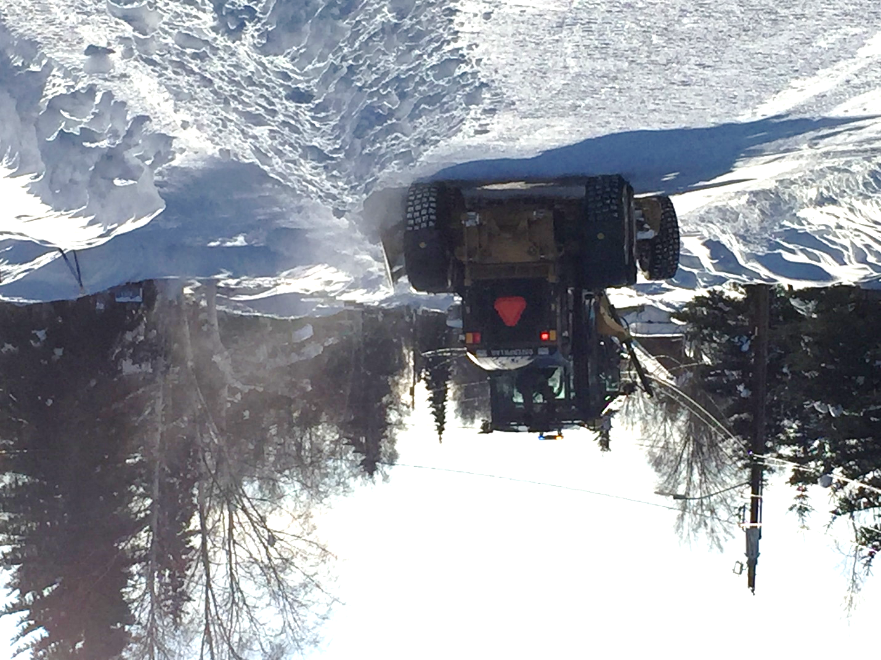

The mission of the Public Works Department is to provide cost-effective and responsive service to maintain safe streets and sidewalks for motorists and pedestrians. The winter season is especially challenging due to so many variables that are hard to control; the frequency of snowstorms, extreme cold temperatures, equipment repairs, experience of temporary employees and available funds. These variables can and will impact Public Works snow and ice removal policies and procedures.

Let’s all work together and have a safe winter season.

